Venue Infrastructure

Note that most of the information in this report was obtained on a visit to the ASB Stadium by Karanjit Gahunia on the 30th of June. Brian Tomlinson, the general manager of ASB Stadium, was interviewed during this visit. The findings are based on the interview as well as observations made on this visit. Photos were taken during this visit and Mr Tomlinson has given permission to use those photos in this report.

# Venue Information

### Venue Size

The Auckland MATHEX events are held at the ASB Stadium in Kohimarama. The main gym is used for this event which spans over 2 days, with 2 sessions each day. The main gym floor is 45m × 30m (1350 sq/m) and has a floor above with seating for approximately 3500 people. In previous MATHEX events, there have been approximately 5000 people in attendance each day (between the 2 sessions).

### Unused Seating Section

The layout of MATHEX competitions at ASB Stadium can be seen in figure 1. In previous years, the seating section behind the judges has been completely closed off (figure 2). This is to prevent spectators from cheating by seeing the answer sheets that the judges have. However, in recent years, higher rows of seating have been opened due to high attendance at these events.

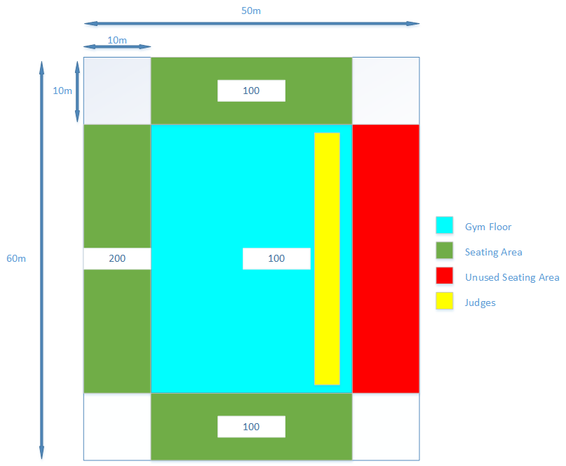

Figure 1. MATHEX competition layout at ASB Stadium

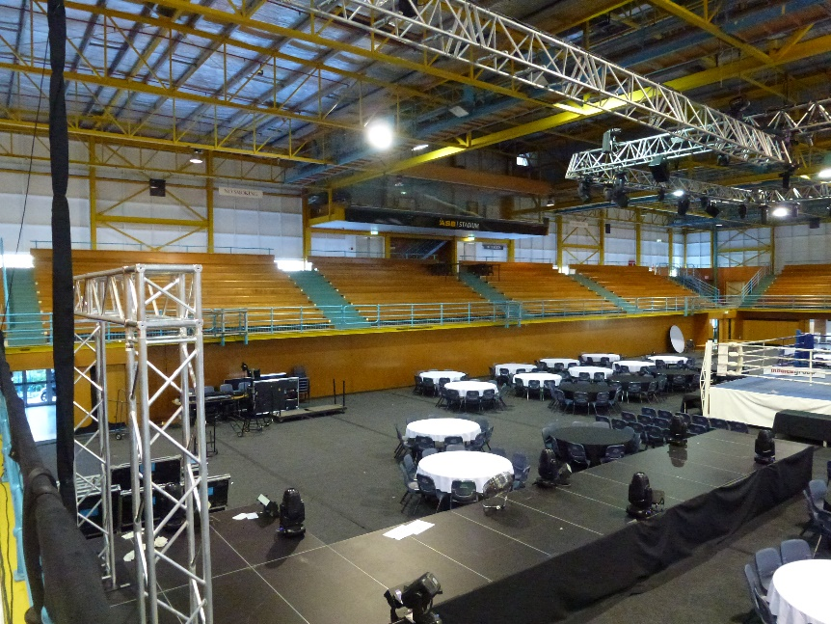

Figure 2. Unused stand during MATHEX

# Networks

### Overview

There are 2 Wi-Fi networks installed in the main gym area of ASB Stadium. The first network belongs to the stadium itself whereas the second network belongs to Selwyn College. Both networks have one access point each installed in the main gym (figure 3). According to Mr Tomlinson, both networks can potentially cover the entire main gym area.

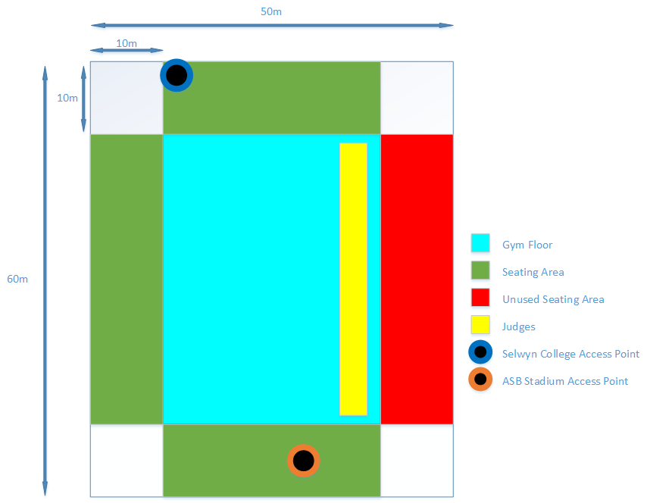

Figure 3. Location of Access Points in the main gym

### ASB Stadium network

The ASB Stadium network is a broadband internet network. The access point is located under the seating area. There are other access points located in the stadium that are also connected to this network (e.g. reception area). A speed test of the network showed that the connection had 17 ping, 15 Mb/s download, and 12 Mb/s upload. Mr Tomlinson says that adding repeaters would extend the range to cover the main gym area. The stadium is open to us bringing our own equipment to install and utilise along with their network.

### Selwyn College network

The Selwyn College network is a fibre internet network. There is one access point installed in the main gym area (figure 4). Permission to utilise the network would have to be requested from the Maths department of Selwyn College. There is no speed test data for this network.

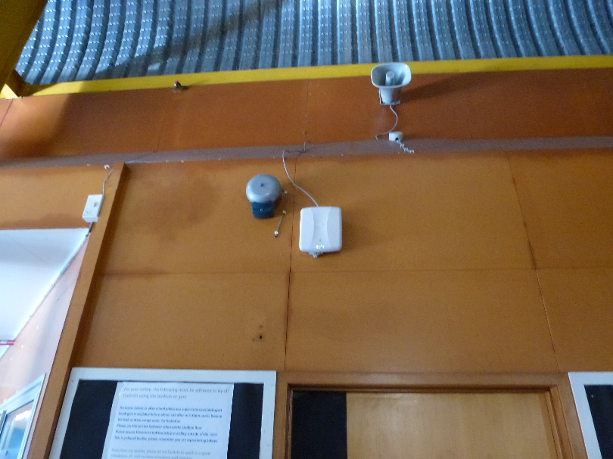

Figure 4. Access Point for the Selwyn College Wi-Fi network

# Existing Equipment

Scoreboard Display  
There is no projector screen or other type of display installed in the main gym area. However, there is plenty of space to install a temporary screen and projector for a big scoreboard display. Mr Tomlinson recommends using a space in the unused seating section (figure 5) as it has been used in the past for similar uses. This location would be visible from most spots for spectators as well as competitors in the MATHEX competitions.  
  
Network and Server Equipment  
There is no existing equipment such as access points, wireless repeaters, or servers that could be used for the Real-Time Scoreboard System implementation at the stadium.

# Further Research Areas

Some of the areas that require further research include:

* The capacity and range of access points installed in the main gym.
* The type of equipment (if required) for extending the existing networks.
* Permission regarding the use of the Selwyn College network.
* Speed of the Selwyn College network.